Chapter 3

Analysis and Design

3.1 Introduction

This chapter covers the analysis and design of the considered system.

3.2 Idea Matrix

Table 3.1 Idea Matrix
Idea Matrix
Increase | 1)It increases Network security  2)It increases network monitoring | 1)Network security  2) Network monitoring
Improve | 1)It improves zero-day attack detection  2)Improves IoT security  3) Improves awareness of user about network intrusions | 1)Unknown attacks  2)IoT security  3) User awareness
Ignore | 1)It ignores the normal behavior in the network | 1)Normal behavior
Deliver | 1)It delivers efficient intrusion detection system for IoT devices | 1)IoT security
Document | 1)Documentation of the project for researchers to understand and improve on the project in the future. | 1)Project documentation
Decrease | 1)It decreases efforts taken to create signatures | 1)Effort
Educate | 1) Educate project members with security concepts, machine learning, MySQL, Wire- shark  2) Educate user | 1)Project members  2)User
Evaluate | 1)Continuously monitor network traffic for intrusions  2)Evaluate packets to determine if there is an intrusion | 1)Network Traffic  2)Packets
Experiment | 1)Experiment on different types of attacks  2) Experiment on different types of ML models | 1)Attacks  2)ML Models
Accelerate | 1)It increases the processing speed by using a separate device instead of the IoT device itself | 1)Processing speed
Analysis | 1)It analyses detected anomalies to deter- mine what type of attack it is | 1)Category of attack
Advertise | 1)Advertise about IoT security and need of an IDS  2)Create a GitHub page, which will include code, documentation and process | 1)Security awareness  2) GitHub

3.3 Mathematical Model

Let S be the solution set for the given problem statement.
S = { Input, Function, Output, Terminate, Success, Failure }.
Where,
Input = Input to the System.
Function = Functions of the system.
Output = Output of the system.
Terminate = Terminating Condition of the System.
Success = Success cases for the System.
Failure =Failure cases for the system.
1. Input = { UserName, Password, Data Packets }
a. UserName :- use rid
b. Password : user passsword
c. Data Packets:- A data packet is a unit of data made into a single package that travels along a given network path.
2. Function = { Login auth, Network connection, train test, intrusion detection, Notification }
a. Login auth: This function will take Username and Password as the input and gives the authorization rights to the user accordingly.
IF Y = F(X) is the login auth function then
X: - Username and Password taken as an input.
Y: - Authorization rights of a user.
b. Network connection = This function will take port number, IP address as an input to give the status of the connection network.
IF Y=F(X) is the Network Connection Function, then
X:- Inputs to setup a network, connecting to a device ,routing the incoming data and device configuration.
Y:- Status of the network connection.
c. train test: This function will take features as an input to give the accuracy of the model and further it will be turned to improve the accuracy of the model. Ran- dom Forest has been used as a Machine learning algorithm for building the model.
IF Y=F(X) is the function to test and train the model then,
X:- Features of the DS2OS dataset as an input.
Y:- Accuracy of the model
d. intrusion detection : This function will take features like sourceID, sourceAddress, sourceType, sourceLocation, destinationServiceAddress, destinationServiceType, des- tinationLocation, accessedNodeAddress, accessedNodeType, operation, value, times- tamp as an input and notifies the user the system for the intrusion.

• Random Forest Classifier has been used for the building and implementing the model.
Basically, a random forest is an average of tree estimators. As with nonparametric regression, simple and interpretable classifiers can be derived by partitioning the range of X.
Let n = A1, . . . , AN be a partition of X. Let Aj be the partition element that contains x. Then h(x) = 1 if XiAj Yi XiAj (1 Yi) and h(x) = 0 otherwise.
We conclude that the corresponding classification risk satisfies R(h) R(h) = O(n1/(d+2)).
Trees are useful for their simplicity and interpretability. But the prediction error can be reduced by combining many trees.
These are bagged trees except that we also choose random subsets of features for each tree. The estimator can be written as
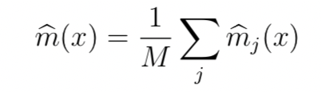
where mj is a tree estimator based on a subsample (or bootstrap) of size a using p randomly selected features. The trees are usually required to have some number k of observations in the leaves. There are three tuning parameters: a, p and k. You could also think of M as a tuning parameter but generally we can think of M as tending to . For each tree, we can estimate the prediction error on the un-used data. (The tree is built on a subsample.)
Averaging these prediction errors gives an estimate called the out-of-bag error estimate.
IF Y=F(X) is the function then,
X: sourceID, sourceAddress, sourceType, sourceLocation, destinationServiceAddress, destinationServiceType, destinationLocation, accessedNodeAddress, accessedNode- Type, operation, value, timestamp as an input
Y: Notifies the system.
e. Notification: This function takes the input which is provided by the function (intrusion detection) and notifies the user.
IF Y=F(X) is the function then,
X: Output of the function(intrusion detection).
Y: Intrusion message to the user.
3. Output = { display intrusionmsg }
a. display intrusionmsg : display error message if any intrusion occurs.
4. Intermediate Results
a. Successful working of module.
b. Successful Working of Network.
c. Successful User authentication.
5. Terminate = { Invalid details, Network failure, Timeout}
a. Invalid User Authentication.
b. Network failure
c. timeout
6. Success
a. Successful user login.
b. Successful connection establishment of nodes and ids.
c. Successful detection of intrusion.
d. Displaying the results.
e. Appropriate error messages in case of invalid input.
7. Failure
a. Web app Failure.
b. Hardware faults.
c. Network establishment failure.
d. Not displaying required results.

3.4 Feasibility Analysis

The problem is to detect an intrusion in a Iot network. The main objective of our project is to provide a real-time solution for any possible intrusions. In the proposed system, we are planning to use anomaly-based detection system. The anomaly-based intrusion detection system comes into eﬀect when detecting newer attacks, that are not ﬁltered by the ﬁrewall. Random Forest is an ensemble model of decision trees.
Training Complexity: O((nˆ2)pntrees) Prediction Complexity: O(pntrees)
Calling n the number of training sample, p the number of features, ntrees the number of trees (for methods based on various trees), where, n= 21000 (Approx) p = 17 ntress= 4
Hence O(pntrees) runs in polynomial time complexity. The algorithm falls in P. Hence, the given problem is NP.

3.5 Architecture Diagram

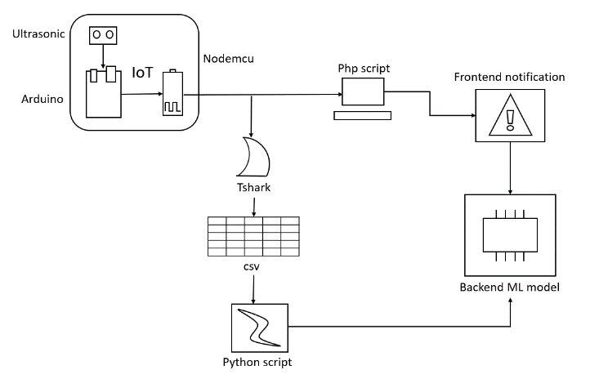
Fig 3.1 Architecture Diagram

3.6 UML Diagrams

3.6.1 Use case diagram

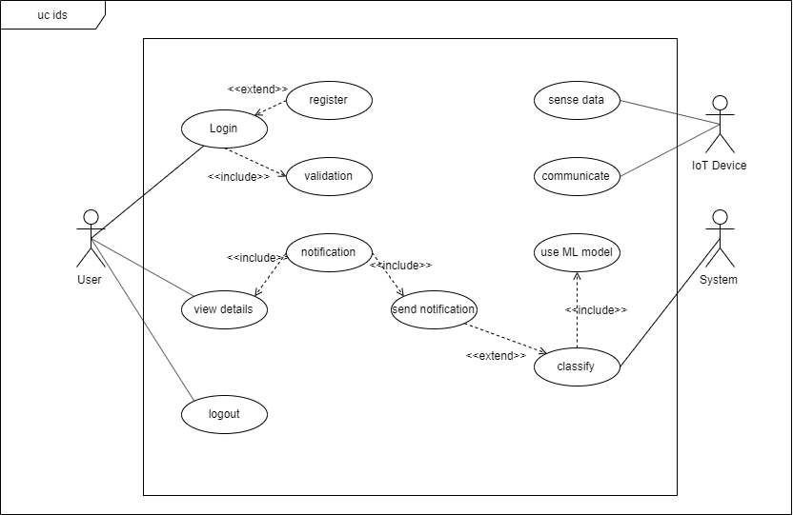
Fig 3.2 Use Case Diagram

3.6.2 Activity Diagram

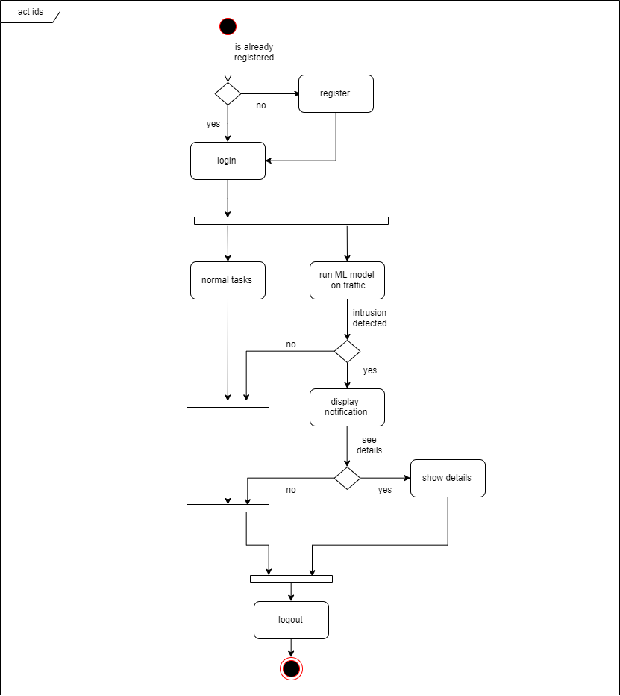
Fig 3.3 Activity Diagram

3.6.3 Class Diagram

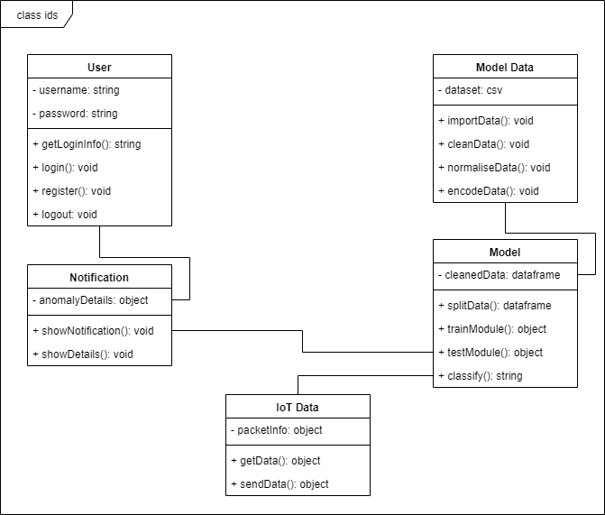
Fig 3.4 Class Diagram

3.6.4 Sequence Diagram

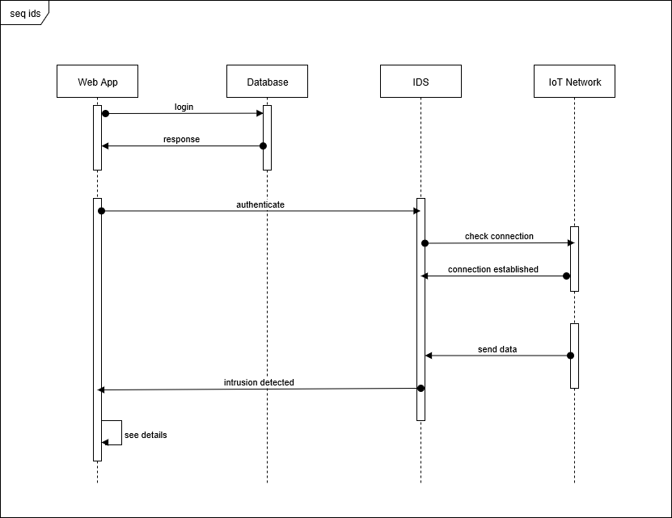
Fig 3.5 Sequence Diagram

3.6.5 Package Diagram

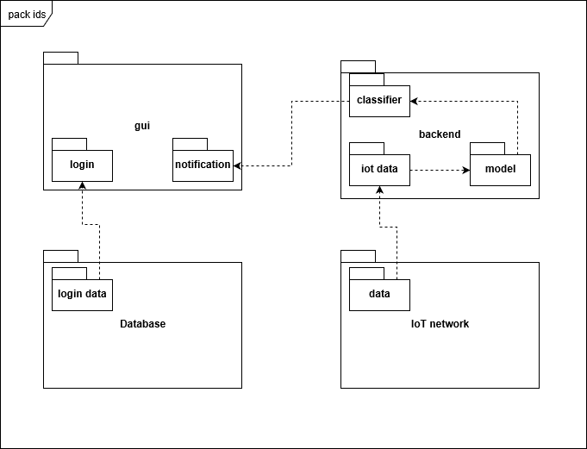
Fig 3.6 Package diagram

3.6.6 State Machine Diagram

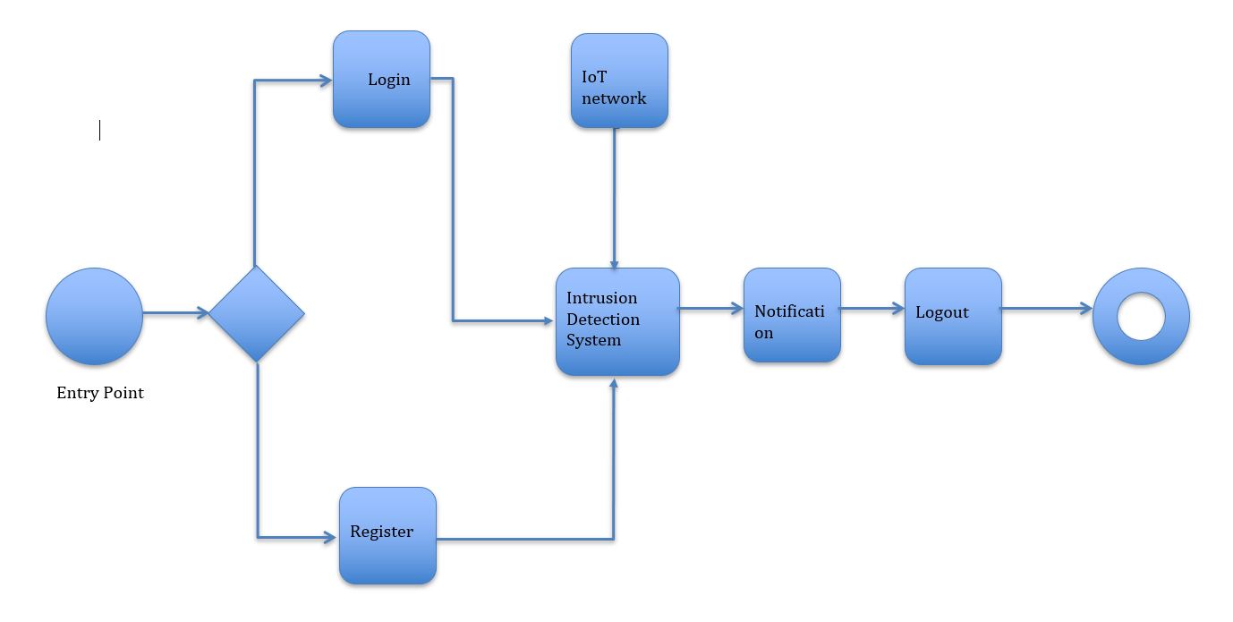
Fig 3.7 State Machine Diagram

3.6.7 Deployment Diagram

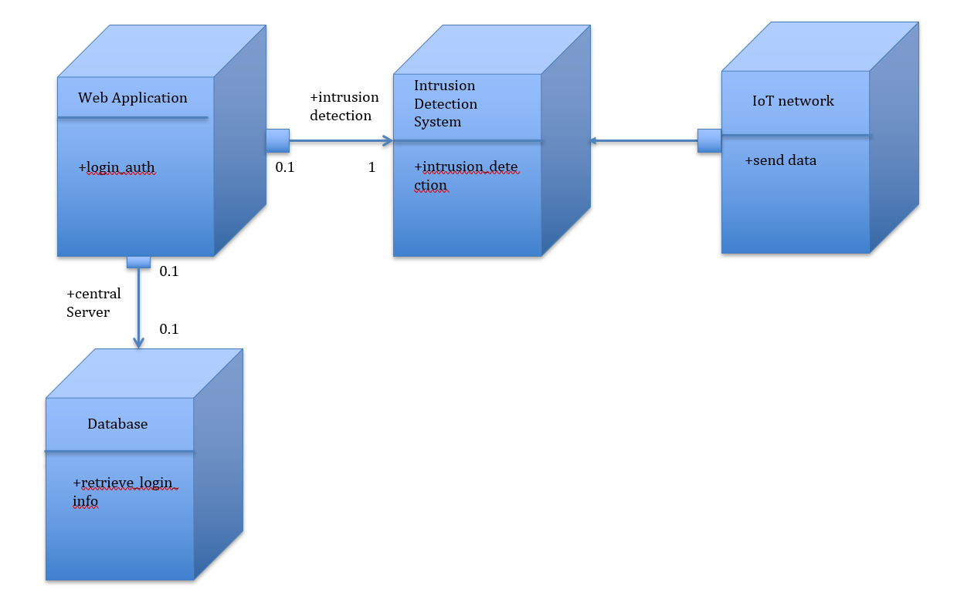

Fig 3.8 Deployment Diagram

